Math Attachment Week # 2
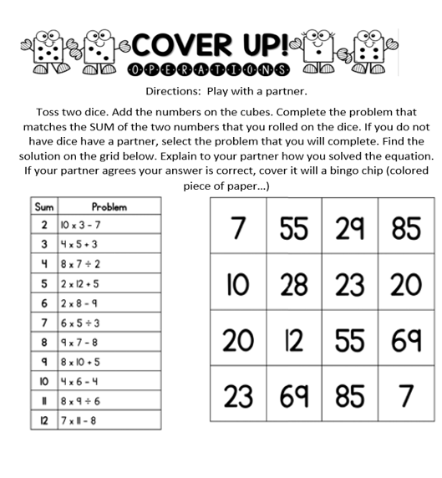
Game of the Week - Play a game of Operations Cover Up

Journal Entry
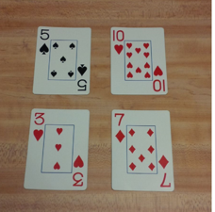
Which one does not belong?
Look at the four images in the picture and explain WHY YOU THINK one does not belong. I am not looking for ONE right answer, there are many right answers. I am looking for the one that you think is correct.

Operations Practice:
1) 789 + 341 = Estimate_________ Actual: _________
2) 9.1 + 9.7 = Estimate___________ Actual: _________
3) 2975 - 604 = Estimate _________ Actual: _________
Problem of the Week:
- During the summer 158 941 people visited Yellowstone National Park. During the fall’ there were 52 397 visitors. How many more visitors went to the park in the summer than the fall?

- A camper hikes 53 741 meters out into the wilderness. On his return trip he takes a shortcut, walking 36, 752 meters back to his cabin. The shortcut saves him 16 998 meters of hiking. True or False, how do you know?

